Title in Cambria typeface, 14pt, left alignment, bold

First Author,¹∗ Second Author,^{1,2} Third Author², Fourth Author^{1,3}
¹ Department, Affiliation, City, Country; ² Department, Affiliation, City, Country; ³ Department, Affiliation, City, Country.
Abstract: Abstract with a minimum length of 180-200 words contains the background, aims, research methods, results and analysis, and conclusions. The abstract written in 9pt Cambria typeface. The abstract as much as possible uses positive sentences. Introduction and aims emphasizes the urgency of the research carried out. Method describes the research method carried out. It may include the theory used to perform the analysis. Results shows and describe the data. Analysis and discussion compare the results with related theories or previous related research. Conclusion contains the generalization or new findings that answer the research question(s). Quotations or references are not permitted in abstract. The first assessment when the article is submitted to the editorial staff is on the abstract, if the abstract is not convincing, it is possible that the article will not continue to the next process. A good abstract is one that can give an overall picture of the article. Keywords are filled with the main concepts discussed in the article, arranged in alphabetical order and separated by semicolons. The number of keywords is three to five words or phrase.
Citation (APA):
Widiyanto, N., Widyaningsih, R., Suhartapa, S. (2023). Contesting identity through the market: Tourism and indigenous movement in Kasepuhan Ciptagelar, West Java. Ibda': Jurnal Kajian Islam dan Budaya, 21(1), 37-56. https://doi.org/10.24090/
ibda.v21i1.7781

Submitted: Xxx x, 2023
Accepted: Xxx x, 2023
Published: Xxx x, 2023

Copyright © 2023 Authors

Submitted for possible open access publication under the terms and conditions of the Creative Commons Attribution-ShareAlike 4.0 International License.

Keywords: Keyword 1; keyword 2; keyword 3; keyword 4; keyword 5

A. Introduction
The introduction contains the background to the problem and the urgency of the research. The introduction also contains the theoretical framework used to perform the analysis. The introduction also contains similar studies that have been previously conducted by other researchers to see the research gaps. Avoid including definitions that have become common knowledge, for example “the definition of culture is… ..”, “the definition of Islamic studies is….”, And other similar definitions. The background, research problems, literature reviews, and theoretical studies must refer to the primary sources, namely from national or international scientific journal articles, it would be better if the articles are published by accredited national journals and reputable international journals within the last 10 (ten) years. References from textbooks, popular books are only secondary references. The minimum number of references as reference material is 20 with a minimum percentage of 80% coming from journal references.

B. Methods
This section provides an overview of the research methods utilized throughout the research process. It should outline the variables under study, the participants involved, the research tools used (including their names, item numbers, and reliability coefficients), as well as the statistical analysis methods employed. Sufficient details should be included to facilitate future research endeavors.

C. Results and Discussion

Sub section

Sub-sub section (if there are)
Begin the results section with a brief introduction that summarizes the aim or objective of the study. This sets the context for the subsequent presentation of the results. Present the collected data in a clear and organized manner. This can be achieved using tables, figures, graphs, or charts, depending on the type of data and the research objectives. Each table or figure should be numbered and accompanied by a descriptive title or caption.

Figure 1
This is an example of an image caption
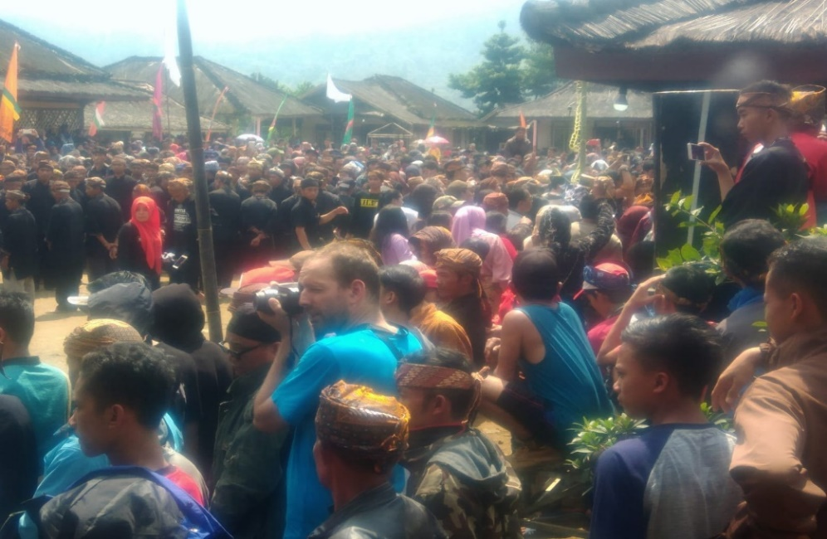
Detail for placing figure, table, and other elements, please check Tables and figures (apa.org)

Table 1
This is an example of table caption
Level | What to see
subject-object Position | How is the event seen, from whose perspective is the event seen? Who is positioned as the narrator (subject) and who is the object being told (TKI). Does each actor and social group have the opportunity to present themselves, their ideas are displayed by other groups.
Position | How the position of the reader is displayed by the author in the text. How is the position of the reader? The reader positions himself in the displayed text. To which group does the reader identify?

D. Conclusion
The conclusion does not contain a summary of the article from introduction to analysis. The conclusion contains the important points, or the findings of the researcher regarding the research he is conducting. Or in other words, the conclusion answers the urgency of the research presented in the introduction.
References or bibliographies are recommended to use reference management software namely Zotero, Endnote, or Mendeley and use the APA (American Psychological Association) style citation.

References
Abdullah, M. (2012). Green vision dalam tradisi kearifan syariah Islam. Ibda’: Jurnal Kajian Islam dan Budaya, 10(1), 30–46. https://doi.org/10.24090/ibda.v10i1.47
Adams, V. (1996). Tigers of the snow and other virtual sherpas: An ethnography of Himalayan encounters. Princeton University Press.
Aly, H. (2015). Syariat dalam balutan ibadat dan adat. Ibda’: Jurnal Kajian Islam dan Budaya, 13(2), 97–111. https://doi.org/10.24090/ibda.v13i2.664
Benda-Beckmann, F. von, & Benda-Beckmann, K. von. (2011). Myths and stereotypes about adat law: A reassessment of Van Vollenhoven in the light of current struggles over adat law in Indonesia. Bijdragen Tot de Taal-, Land- En Volkenkunde / Journal of the Humanities and Social Sciences of Southeast Asia, 167(2/3), 167–195.
BPS. (2020). Provinsi Jawa Barat dalam angka. https://jabar.bps.go.id. https://jabar.bps.go.id/publication/2020/04/27/cfab9a400cf304f800182a5f/provinsi-jawa-barat-dalam-angka-2020.html
Buzinde, C. N., Manuel-Navarrete, D., & Swanson, T. (2020). Co-producing sustainable solutions in indigenous communities through scientific tourism. Journal of Sustainable Tourism, 28(9), 1255–1271. https://doi.org/10.1080/09669582.2020.1732993
Carr, A., Ruhanen, L., & Whitford, M. (2016). Indigenous peoples and tourism: the challenges and opportunities for sustainable tourism. Journal of Sustainable Tourism, 24(8–9), 1067–1079. https://doi.org/10.1080/09669582.2016.1206112
Chakim, S. (2022). A review of rituals and local wisdom of indigenous peoples in Indonesia. Ibda’: Jurnal Kajian Islam dan Budaya, 20(2), 181–199. https://doi.org/10.24090/ibda.v20i2.6439
Cohen, E. (2012). Globalization, global crises and tourism. Tourism Recreation Research, 37(2), 103–111. https://doi.org/10.1080/02508281.2012.11081695
Curtin, N., & Bird, S. (2022). “We are reconciliators”: When indigenous tourism begins with agency. Journal of Sustainable Tourism, 30(2–3), 461–481. https://doi.org/10.1080/09669582.2021.1903908
Dolezal, C., & Trupp, A. (2015). Tourism and development in South-East Asia. ASEAS: Austrian Journal of South-East Asian Studies, 8(2), 117–124. https://doi.org/10.14764/10.ASEAS-2015.2-1
Dong, T. B. (2020). Cultural tourism: An ethnographic study of home stay in Briddim Village, Nepal. The Gaze: Journal of Tourism and Hospitality, 11(1), 10–36. https://doi.org/10.3126/gaze.v11i1.26612
Dove, M. (1985). Peranan kebudayaan tradisional dalam pembangunan. Yayasan Obor Indonesia.
Fang, W.-T. (2020). Cultural Tourism. In W.-T. Fang (Ed.), Tourism in emerging economies (pp. 75–101). Springer Singapore. https://doi.org/10.1007/978-981-15-2463-9_4
Friedman, J. (2000). Cultural identity and global process. SAGE Publications Ltd.
Gamma, G., Sirait, M., N, R., Soenarto, F., & Nurzaman, B. (2005). History of land-use policies and designation of Mount Halimun-Salak National Park. Jurnal Manajemen Hutan Tropika, XI(1), 1–13.
Gedicks, A. (2001). Resource Rebel. South End Press.
Gray, A. (1997). Indigenous rights and development: Self-determination in an Amazonian community. Berghahn Books.
Heffner, R. W. (1999). Geger Tengger: Perubahan Sosial dan Perkelahian Politik. LKiS.
Higgins-Desbiolles, F., Blanchard, L.-A., & Urbain, Y. (2022). Peace through tourism: critical reflections on the intersections between peace, justice, sustainable development and tourism. Journal of Sustainable Tourism, 30(2–3), 335–351. https://doi.org/10.1080/09669582.2021.1952420
Holder, A., Walters, G., Ruhanen, L., & Mkono, M. (2022). Exploring tourist’s socio-cultural aversions, self-congruity bias, attitudes and willingness to participate in indigenous tourism. Journal of Vacation Marketing, 13567667221124344. https://doi.org/10.1177/13567667221124343
Honey, M. (1999). Ecotourism and sustainable development: Who owns paradise? Island Press.
Irianto, S. (2016). Masyarakat adat keindonesiaan. Kompas Daily Magazine.
James, S. (2010). The art of not being governed: An anarchist history of upland Southeast Asia. NUS Press.
Koentjaraningrat. (1993). Masalah kesukubangsaan dan integrasi nasional. Gramedia Pustaka Utama.
Kusdiwanggo, S. (2016). Konsep pola permukiman spasial di Kasepuhan Ciptagelar. Jurnal Permukiman, 11(1), 29–42.
Li, T. M. (2000). Articulating indigenous identity in indonesia: Resource politics and the tribal slot. Comparative Studies in Society and History, 42(1), 149–179. https://doi.org/10.1017/S0010417500002632
Longchar, W. (2014). Tourism Industry-an instrument of neo-liberal economic project: A ministerial challenge. The Asia Journal of Theology, 28(1), 59–69.
Moniaga, S. (2007). From Bumiputera to Masyarakat Adat: The revival of tradition in Indonesian politics. In D. Davidson, J. and Henley (Ed.), The deployment of adat from colonialism to indigenism (pp. 275–294). Routledge.
Mutaqin, Z. Z. (2014). Penghayat, orthodoxy and the legal politics of the state. Indonesia and the Malay World, 42(122), 1–23. https://doi.org/10.1080/13639811.2014.870771
Muttaqin, A., & Noor, N. M. (2022). Local Islam and Javanese culture penetration: Muslim Alif Rebo Wage (Aboge) negotiations in identity formation. Ibda’: Jurnal Kajian Islam dan Budaya, 20(1), 110–130.
Nordholt, H. S. (2007). Bali, Benteng Terbuka 1995-2005: Otonomi daerah, demokrasi electoral dan identitas defensive. Pustaka Larasan.
Peluso, N. L., & Vandergeest, P. (2001). Genealogies of the political forest and customary rights in Indonesia, Malaysia, and Thailand. The Journal of Asian Studies, 60(3), 761–812.
Picard, M. (1996). “Cultural tourism” in Bali: Cultural performances as tourist attraction." Indonesia, 49, pp: 37-74. Archipelago, the University of California.
Putri, S., Sukirno, & Sudaryatmi, S. (2017). Implikasi putas MK terhadap eksistensi hutan adat masyarakat yang tumpang tindih dengan hutan konservasi Taman Nasional Gunung Halimun Salak. Diponegoro Law Journal, 6(35), 1–22.
Rich, B. (1999). Mortgaging the earth: The World Bank, environmental impoverishment and the crisis of development. INFID.
Ricklefs, M. . (2017). Sejarah Indonesia modern. Gadjah Mada University Press.
Robertson, R. (1995). Glocalization: Time-space and homogeneity-heterogeneity. In Global modernities (pp. 25–45). Sage Publications, Ltd.
Royer, S. De, Visser, L. E., Galudra, G., Pradhan, U., & Van Noordwijk, M. (2015). Self-identification of indigenous people in post-independence Indonesia: A historical analysis in the context of REDD+. International Forestry Review, 17(3), 282–297. https://doi.org/10.1505/146554815815982648
Ruhanen, L., & Whitford, M. (2019). Cultural heritage and indigenous tourism. Journal of Heritage Tourism, 14(3), 179–191. https://doi.org/10.1080/1743873X.2019.1581788
Shiva, V. (1998). Staying alive: Women, ecology and survival in India. Zed Book Ltd.
Spradley, J. (1975). Anthropology: The cultural perspective . John Wiley and Sons Inc.
Subur. (2017). Religi Grebeg Sura di Banyumas. Ibda’: Jurnal Kajian Islam dan Budaya, 15(1), 59–75.
Topatimasang, R. (2004). Orang orang kalah. Insist Press.
Trupp, A. (2011). Exhibiting the “other” then and now: “Human zoos” in Southern China and Thailand. ASEAS-Austrian Journal of South-East Asian Studies, 4(1), 139–149.
Tsing, A. L. (2005). Friction: An ethnography of global connection. Princeton University Press.
Webb, R. . (1986). The sickle and the cross: Christians and communists in Bali, Flores, Sumba and Timor. Journal of Southeast Asian Studies, 17(1), 94–112.
Widiyanto, N. (2019). Indigenous religion revivalism and tourism development in Indonesia and Malaysia (A study on Kasepuhan Ciptagelar, West Java and Bundu Tuhan Dusun’s Community in Sabah). Universitas Gadjah Mada.
Widiyanto, N., & Agra, E. (2019). Tourism development and the new path of migration in Sabah, Malaysia. Borneo Research Journal, 13(1), 81–97. https://doi.org/10.22452/brj.vol13no1.5
Widyaningsih, R. (2017). Dimensi sosial dan religi kearifan lokal Banyumas. LPPM Unsoed.

This page has been intentionally left blank.

∗Corresponding Author: First author (firstauthor@affiliation.ac.id), Affiliation, Postal affiliation Address, City, Country.

